How to Install Istation on Computers

- Go to Istation website https://www.istation.com/
- Click on
- Find the Download Istation Tab and click on
- This will come up on the bottom of your screen once it finishes downloading. You will click on it to open it.
- You will then have a window that ask if you want to allow it to download and you click yes.
- This window will come up and you click install. 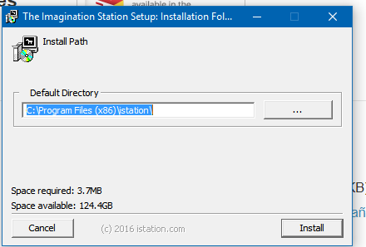
- Then this window. 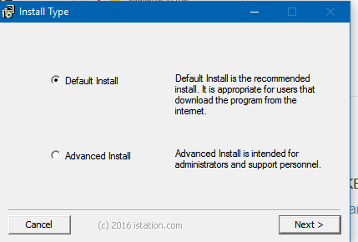 Make sure that Default Install is selected and click next.
- It will then download it and once it comes up you will have to select the school. If you type Corsicana then it will pull up a list of the schools and you select Sam Houston and are ready to go.

